Name: Amal Fouda

Id: 900213020

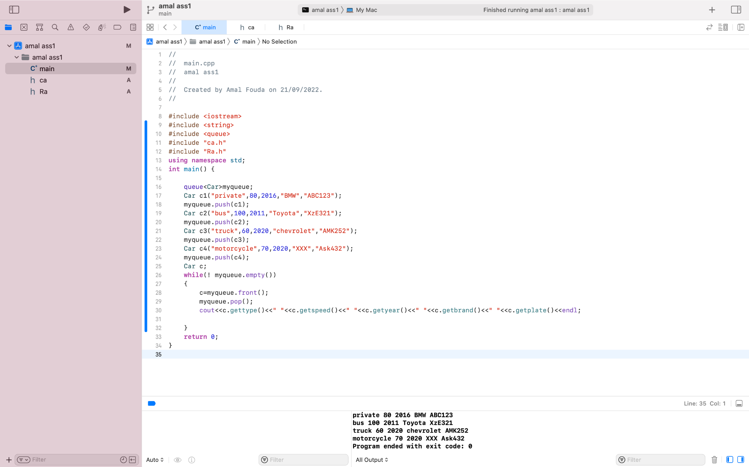

* In the first image I started by seeing if the queue works correctly or not by using a while loop (!myqueue.empty()) to print all the variables of each object in car class.

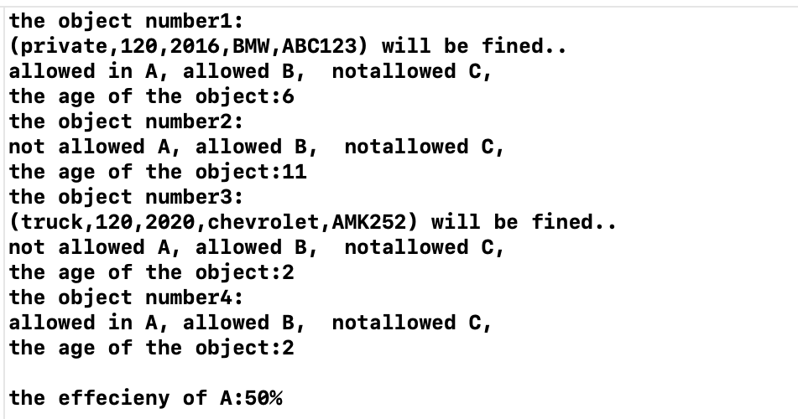

* In the second photo I declare object A from road class to see which objects can pass from road A, and to see which objects will be fined because they exceeded the speed limit, and I used a temporary object of car class to declare the values that front function stands on it, then i pop it and pass it to function allow, radar, age.

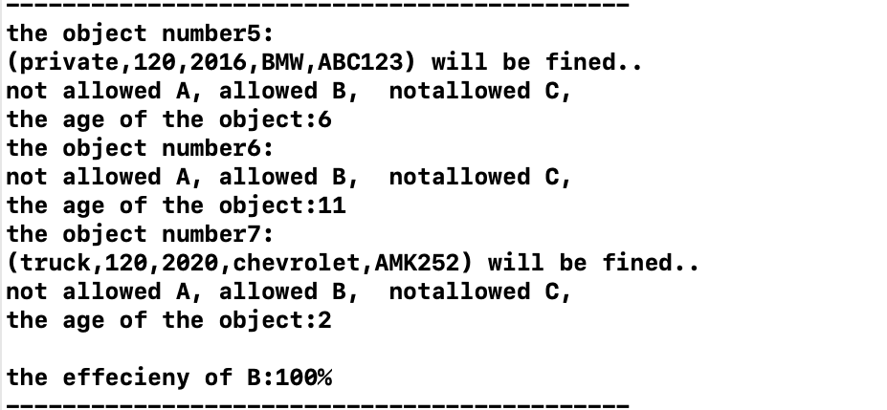

* In the third photo I declare object B from road class to see which objects can pass from road B, and to see which objects will be fined because they exceeded the speed limit, and I used another temporary object of car class rather than the one i used in road A to declare the values that front function stands on , then i pop it and pass it to function allow, radar, age.

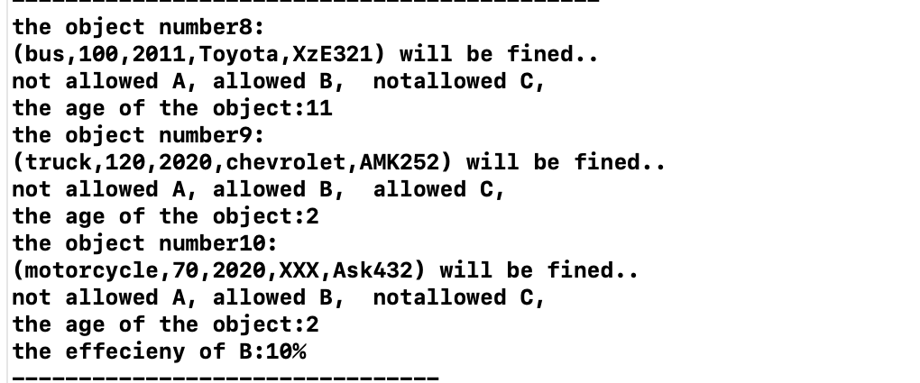

* In the fourth photo I declare object C from road class to see which objects can pass from road C, and to see which objects will be fined because they exceeded the speed limit, and I used another temporary object of car class rather than the one i used in road B and A to declare the values that front function stands on , then i pop it and pass it to function allow, radar, age.
* Important Note, extra adds:
* I used three counters to calculate the efficiency of each road, one called i for road A, and one called J for road C, and another static one to count all the objects that enter car class so it calculates all objects enter the roads and use this number to calculate the efficiency of road B and i incremented the static count in argument constructor because it allows all cars to pass from it. I also used type casting to declare one of the variable to be float while calculating the efficiency of each road, for example, (eff3=(**float**(C.getj())/Car::getcount())*100).
* I did validation for the year model if it is more than 2022 give an error using while loop.
* I made a destructor in car class to decrement static count variable

—--------------------------------------------------------------------------------

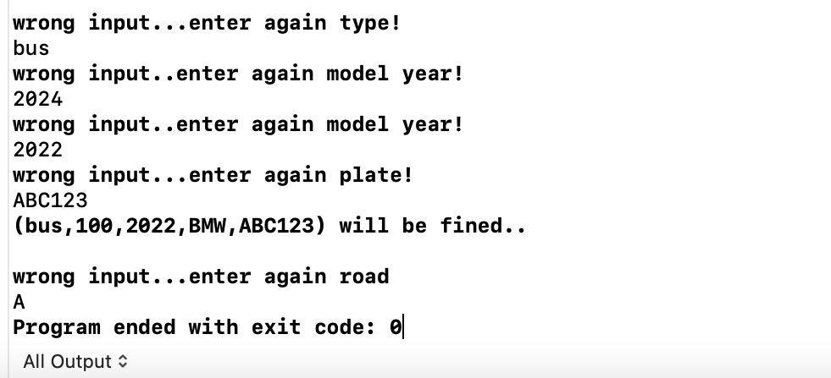

* In the last picture I used the wrong input to test the validation of the car type, car plate, year model and road type.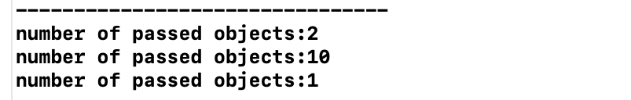
* I printed the number of passed cars on each road.
* —---------------------------------------------------------------
* 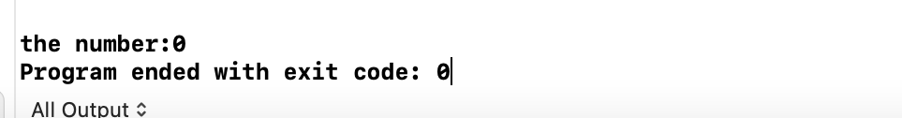
* I used (cout<<"the number:"<<Car::getcount()<<endl;) to make sure that the destructor is working